Market Monitor - Bangladesh - 2026-05

Highlights
The cost of the food basket rose slightly in May, driven by volatile price swings in key commodities, though overall food prices remain significantly lower than the previous year. The Bangladeshi Taka remained stable against the US dollar.
The cost of the food basket increased by ↑0.6% month-on-month but decreased by ↓9.2% year-on-year.
Prices for Eggs (brown) surged month-on-month (↑16.1%), while Onions (imported, China) plummeted (↓23.6%). In contrast, Chili (whole, dry, Indian Teja) continued its strong year-on-year inflationary trend (↑31.0%).
Key Drivers:
• A significant year-on-year decrease in the price of major staples, including Sugar (↓52.3%), Eggs (↓33.2%), and Chicken (↓31.3%), drove the overall annual deflation.
• A sharp monthly spike in the price of Eggs (↑16.1%) was the primary driver of the slight month-on-month increase in the food basket.
• The monthly increase was tempered by steep price drops in key items, notably Onions (↓23.6%) and Chickpeas (↓17.0%).
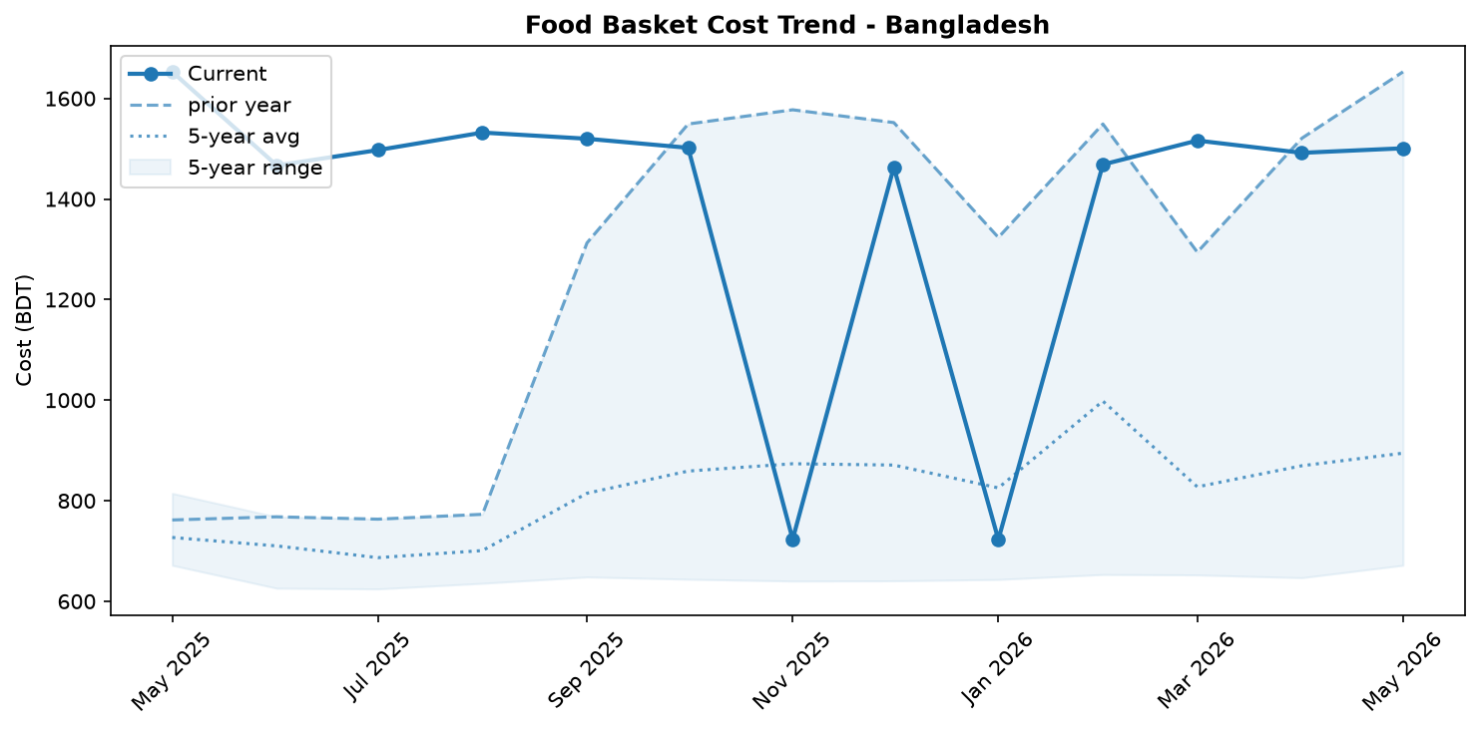
Food basket cost trend

Market Overview
The market for essential foods in Bangladesh remained volatile in May 2026, characterized by conflicting short-term price movements despite a strong annual deflationary trend. The overall cost of a representative food basket is 9.2% lower than a year ago, offering significant relief to consumers. This annual price reduction has been overwhelmingly driven by major price collapses in key staples, including sugar (-52.3%), eggs (-33.2%), and broiler chicken (-31.3%). However, this broader trend is being challenged by recent instability. In the last month, the food basket's cost edged up by 0.6%, signaling a potential slowdown of the deflationary cycle. This monthly uptick was primarily caused by a sharp surge in egg prices, which counteracted steep declines in other commodities like onions. The stability of the Bangladeshi Taka, which depreciated only marginally against the US dollar, helped to contain the cost of imported goods and prevent further upward price pressure. The outlook suggests continued volatility, with the market's direction dependent on whether recent commodity-specific price spikes persist or if broader deflationary pressures reassert themselves. Minor fluctuations around the current price level are expected in the near term.

Commodity Analysis
The performance of individual commodities in May reveals a market pulled in opposing directions. The overall food basket saw a slight 0.6% month-on-month increase, yet remains down by a substantial 9.2% year-on-year. The primary drivers of the annual deflation are sugar and meat. Sugar prices have collapsed by 52.3% compared to last year, though they have now stabilized with a marginal 0.2% monthly increase. Similarly, broiler chicken prices continued their downward trend, falling 3.8% this month and contributing to a dramatic 31.3% year-on-year decrease.
Short-term volatility is best exemplified by eggs and onions. Egg prices, despite being down 33.2% annually, surged by 16.1% in the last month alone, single-handedly pushing the overall basket into positive monthly territory. Conversely, imported onion prices provided significant downward pressure, plummeting by 23.6% month-on-month. In stark contrast to the general deflationary environment, chili (Indian Teja) continues to experience sustained inflation. Its price climbed another 3.1% in May, capping a 31.0% increase over the past year and marking it as a notable outlier. These divergent trends underscore the current instability and unpredictability within the food market.
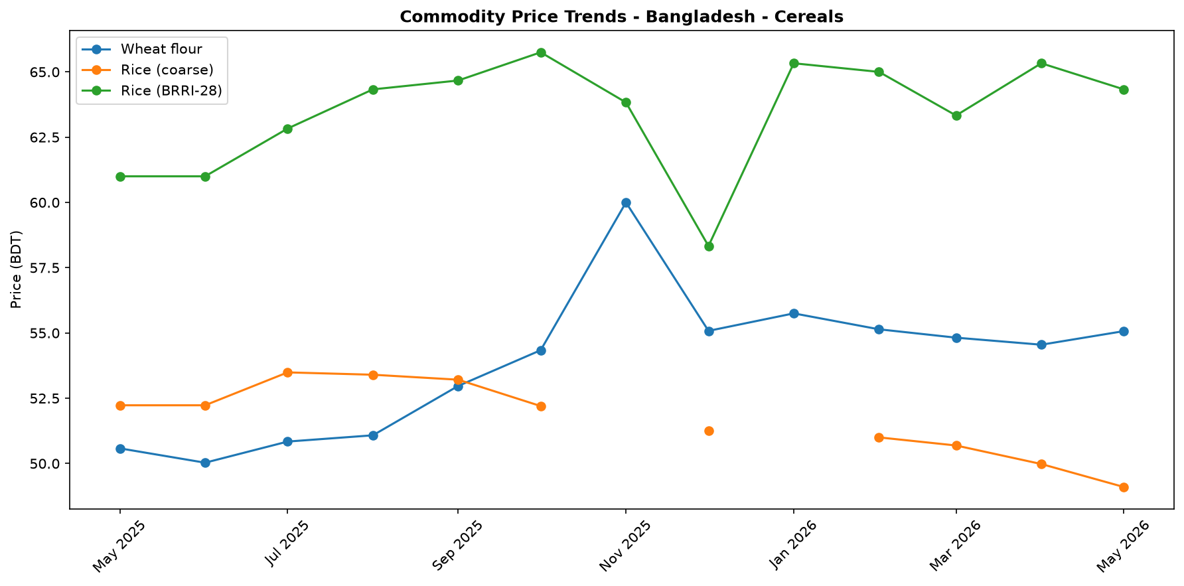
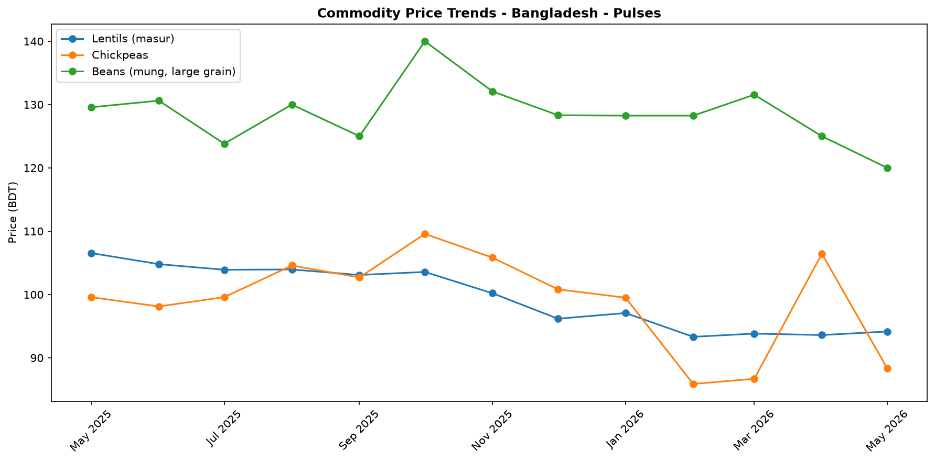
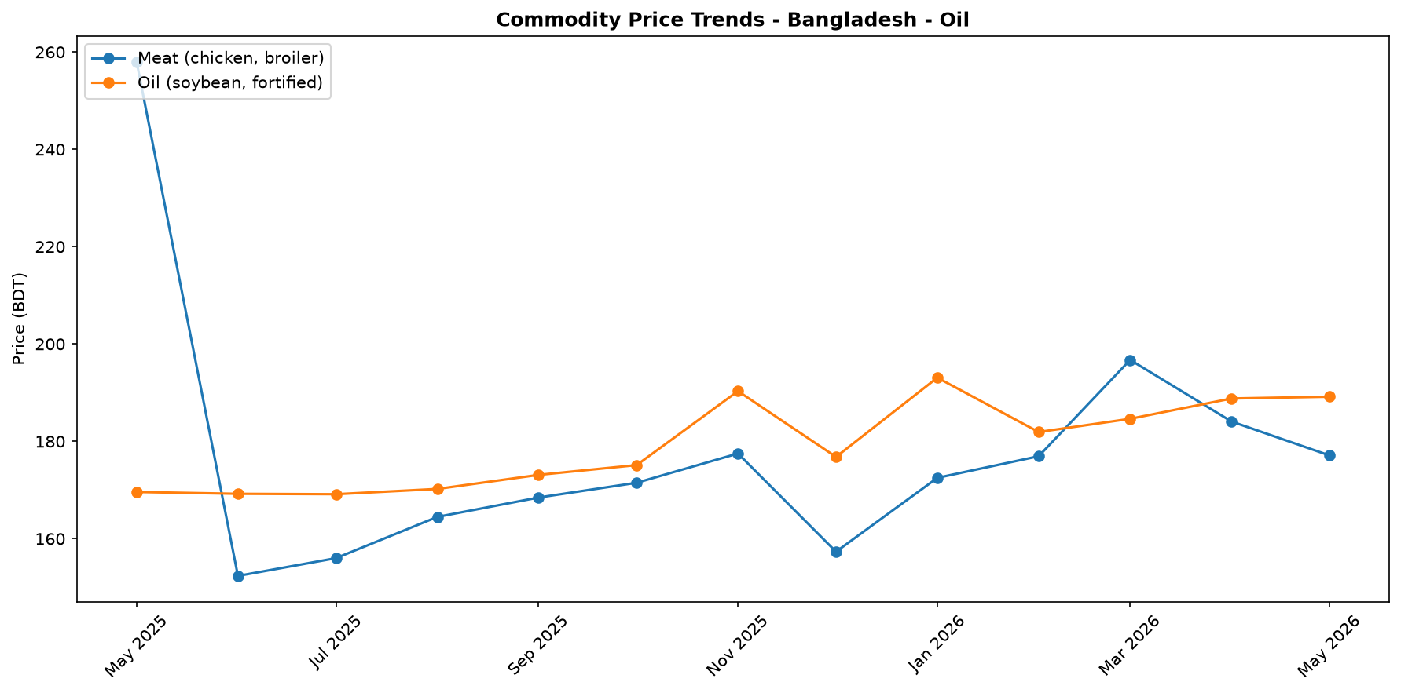
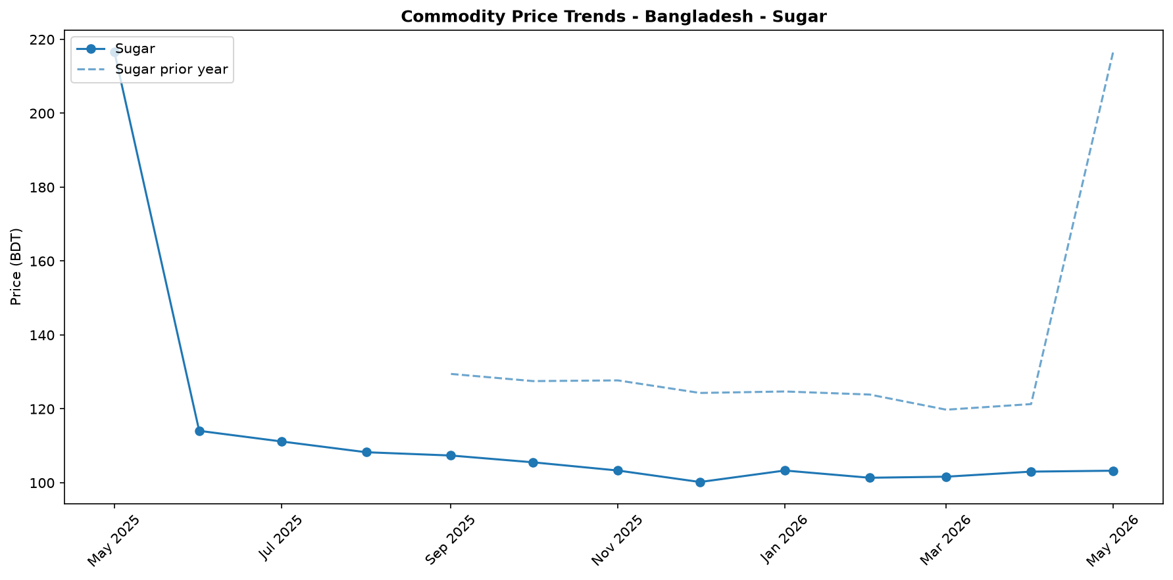
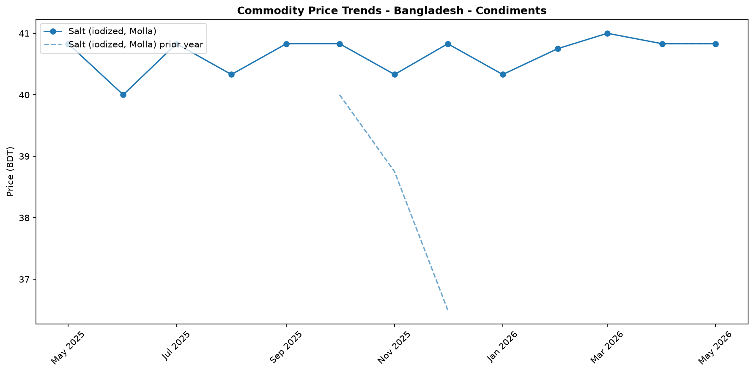
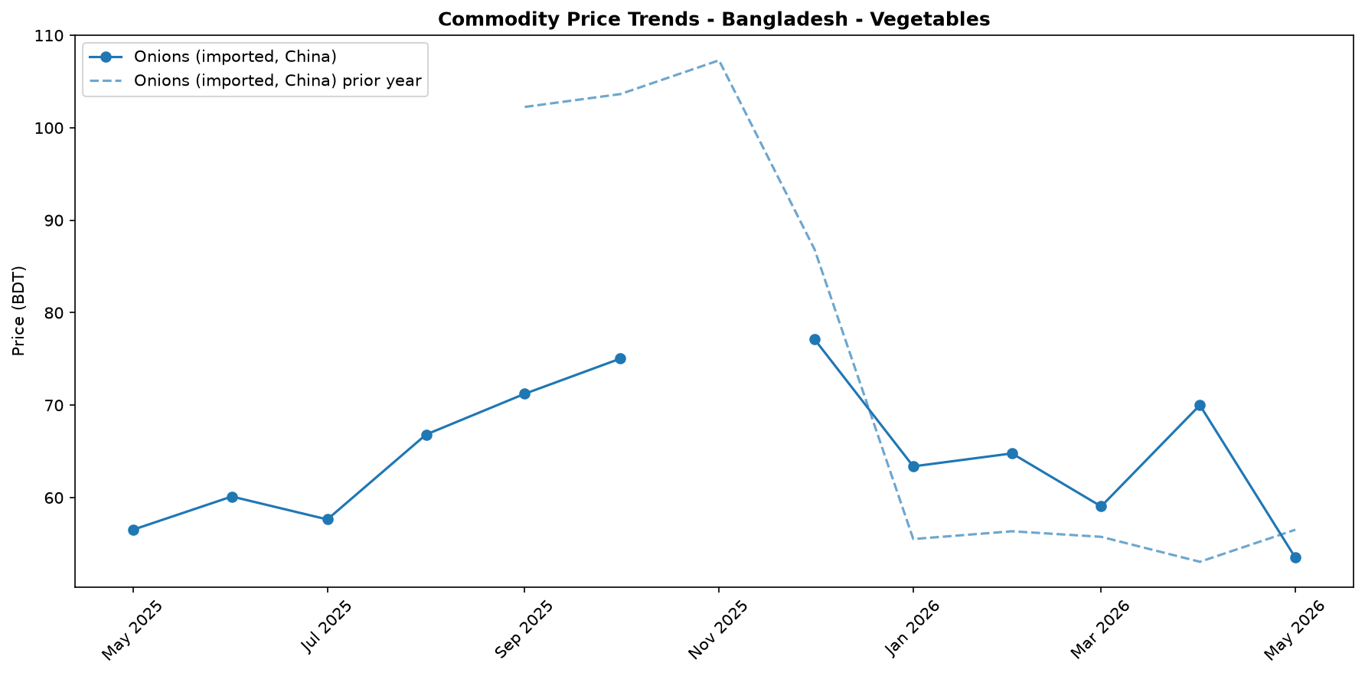
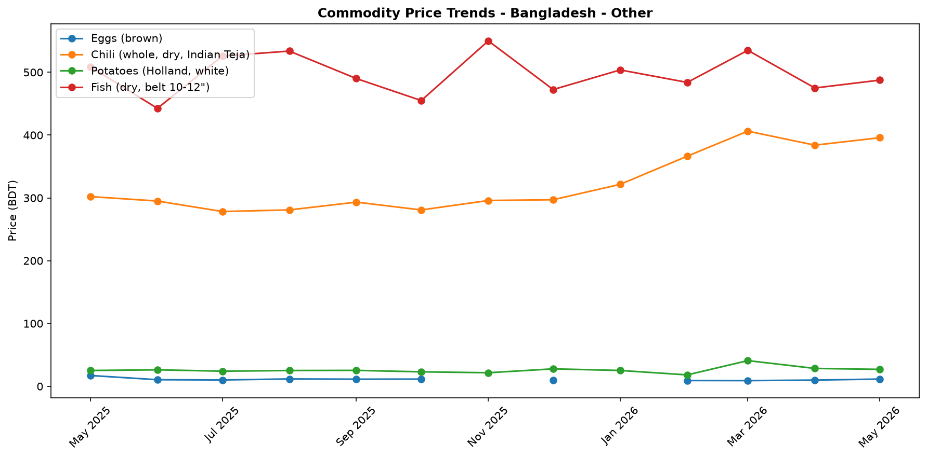

Regional Highlights
Nationally, the food market in Bangladesh presents a complex picture of annual price relief coupled with short-term volatility. While the cost of a standard food basket has decreased by 9.2% over the past year, a recent 0.6% monthly increase highlights underlying instability. This dynamic is driven by contradictory price movements, such as a 16.1% monthly surge in egg prices occurring alongside a 23.6% crash in onion prices.
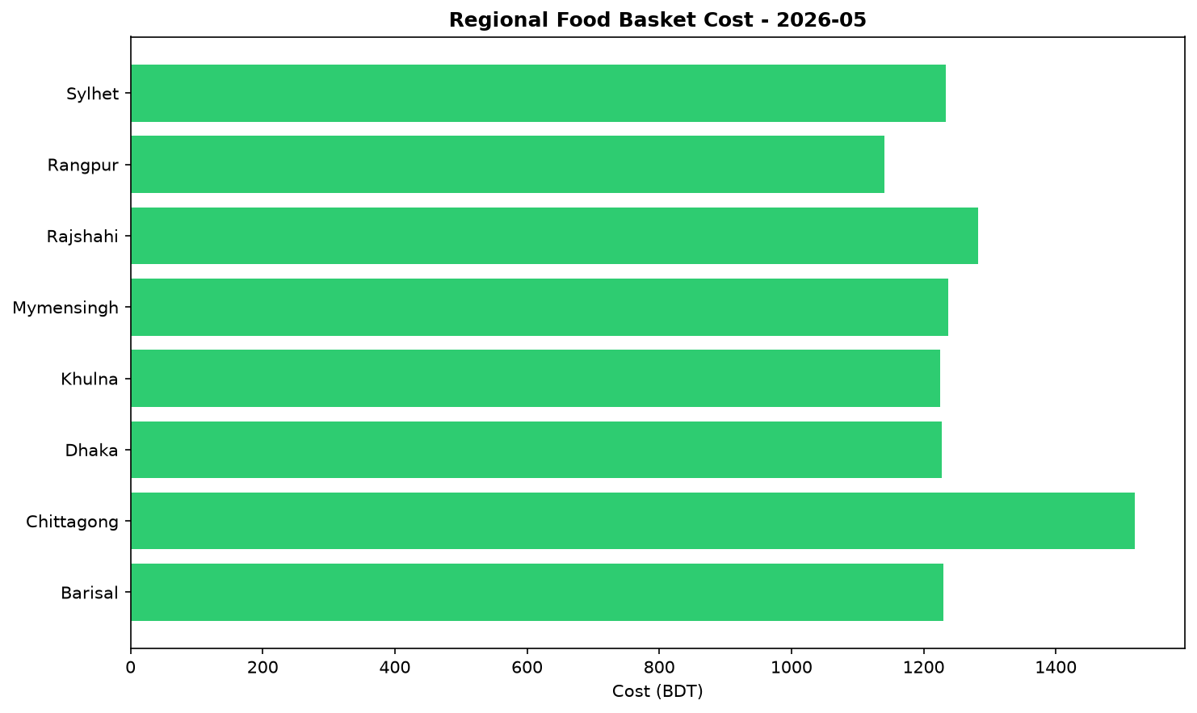
While the national data indicates an easing of food costs compared to the previous year, this does not reflect the acute needs in all areas. Significant humanitarian efforts are ongoing, particularly concerning Rohingya refugee populations. During May, the UN and its partners launched a USD 710.5 million appeal to meet critical needs in Cox’s Bazar and Bhasan Char, and the Government of Finland contributed EUR 2 million to sustain life-saving assistance. These events underscore that despite favorable national price trends for some staples, vulnerable communities, also facing environmental risks like deforestation-related landslides, continue to require substantial economic support to ensure food security.

Exchange Rate Analysis
The Bangladeshi Taka (BDT) remained stable, trading at 122.75 per US dollar. A marginal month-on-month depreciation of 0.04% had a negligible effect on the cost of imports. However, a year-on-year comparison reveals a 0.45% depreciation, indicating a slight but persistent weakening trend over the longer term. This recent stability helps contain immediate price shocks for imported essential commodities such as wheat, cooking oil, and fuel, which are crucial for food security. Nonetheless, the gradual annual depreciation continues to exert modest upward pressure on the domestic prices of these goods. The stability is a positive factor for short-term price predictability, but the long-term depreciation trend remains a point of concern for the affordability of imported food and fuel.

References
- [rw_4214182] ReliefWeb (2026-05-31) Finland boosts support for Rohingya refugees with EUR 2 million contribution [EN/BN]
https://reliefweb.int/node/4214182
- [rw_4214118] ReliefWeb (2026-05-29) Period poverty: A global menstrual health crisis
https://reliefweb.int/node/4214118
- [rw_4213869] ReliefWeb (2026-05-28) Asia and the Pacific: Weekly Regional Humanitarian Snapshot (19 - 25 May 2026)
https://reliefweb.int/node/4213869
- [rw_4213682] ReliefWeb (2026-05-26) Homestead Gardening Guidelines - Vegetable production for household consumption using minimal space in Rohingya camps and host communities
https://reliefweb.int/node/4213682
- [rw_4212820] ReliefWeb (2026-05-20) UN and partners appeal for USD 710.5 million to meet the critical needs of Rohingya refugees and Bangladeshi host communities [EN/BN]
https://reliefweb.int/node/4212820
- [rw_4212682] ReliefWeb (2026-05-19) From coverage to prioritisation: how funding cuts are reshaping operational decisions in Cox’s Bazar
https://reliefweb.int/node/4212682
- [rw_4212292] ReliefWeb (2026-05-15) Impact of gardening and nutrition support provided to women in refugee camps in Cox’s Bazar
https://reliefweb.int/node/4212292
- [rw_4212129] ReliefWeb (2026-05-14) Mr. Tom Fletcher, Under-Secretary-General for Humanitarian Affairs and Emergency Relief Coordinator – Remarks to the press on US humanitarian funding at UN Headquarters, 14 May 2026
https://reliefweb.int/node/4212129
- [rw_4212067] ReliefWeb (2026-05-14) Sweden announces more than SEK 2.7 billion in humanitarian assistance to the world’s most vulnerable
https://reliefweb.int/node/4212067
- [rw_4211766] ReliefWeb (2026-05-13) UNHCR Regional Bureau for Asia and Pacific: Myanmar Situation Update (Bangladesh, India, Indonesia, Malaysia, Myanmar, and Thailand) January - March 2026
https://reliefweb.int/node/4211766
- [seerist_1028666] Seerist (2026-05-22) Tiger kidnaps to remain rare despite incident involving bank manager in Dhaka district
- [seerist_1028464] Seerist (2026-05-08) Big Picture series: Keep calm and kharif on – fertiliser shock and political risk in South Asia
- [seerist_1028203] Seerist (2026-04-17) Operational, integrity risks to persist in renewable energy sector despite government support
- [seerist_1028169] Seerist (2026-04-16) Political interference, integrity risks likely to remain prevalent in banking sector despite reforms
- [seerist_1028140] Seerist (2026-04-14) Uneven enforcement of new labour law will sustain reputational, unrest risks in manufacturing
- [seerist_1028118] Seerist (2026-04-13) Big Picture series: Asian economies face prolonged energy stress as Middle East disruption persists
- [seerist_1028051] Seerist (2026-04-07) Civil unrest risks to increase amid differences over political reforms

